Group 5 SQL Basic Activity

1. What is the output of this query?

SELECT \* FROM Booktable WHERE PurchaseCost>12;

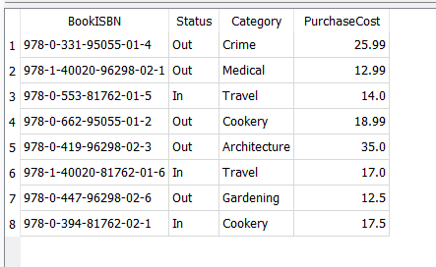

2. What is the output of this query?

SELECT DISTINCT Category from Booktable;

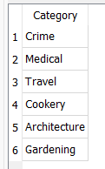

3. Write a SQL query to retrieve all the data from Book where Status equals “out”.

SELECT \* from Booktable where Status = "Out";

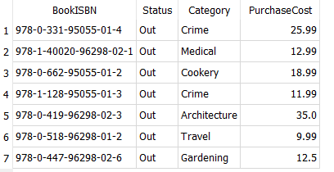

4. Write SQL statement to retrieve only the first 3 rows from book.

SELECT \* FROM Booktable LIMIT 3;

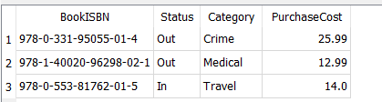

5. Write a SQL statement to count all books where the Category equals Travel.

SELECT \* FROM Booktable WHERE Category = "Travel";

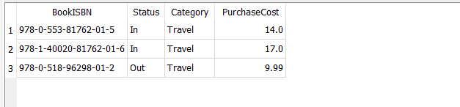

6. Write SQL statements to delete the books with ISBN of “978-1-119-95055-02-4, 978-0-261-81762-01-2”

DELETE FROM Booktable WHERE BookISBN in ('978-1-119-95055-02-4','978-0-261-81762-01-2');

